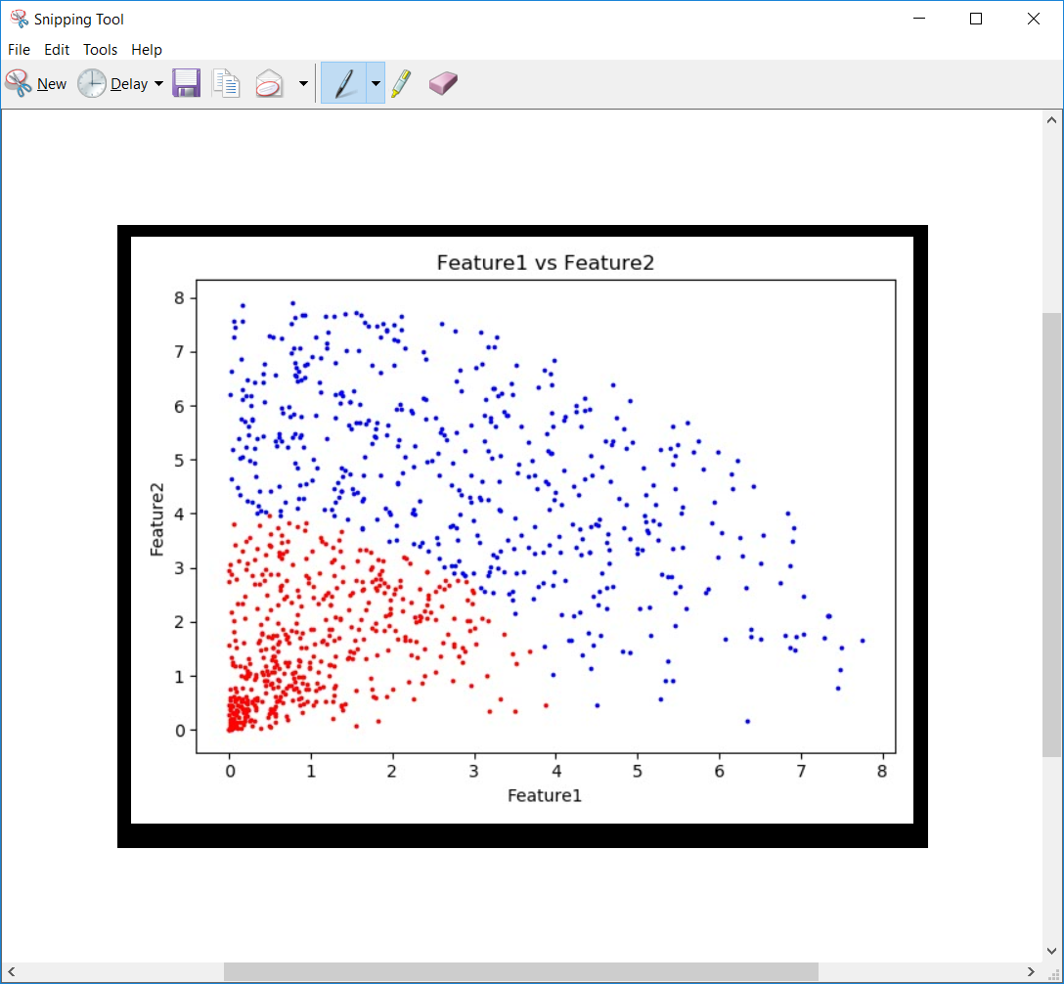

The best features :-
- We can see a significant difference between the the regions of label 1 and label 2
- Easily differentiated ( do not overlap)

These two features are best seen the over plot

